**Difference between Document and Window object**

Document object:

* The Document object represents a webpage that is loaded in the browser.
* It is a object of window property.
* The document can be accessed by using window.document property.
* The Document and window object have some same method name but different behaviour.
* The browser creates a document object model of the page when it is loaded.
* It is the root element that represents the html document.
* For example

Window.open() opens a new tab or window.

Document.open() opens a blank document within the window.

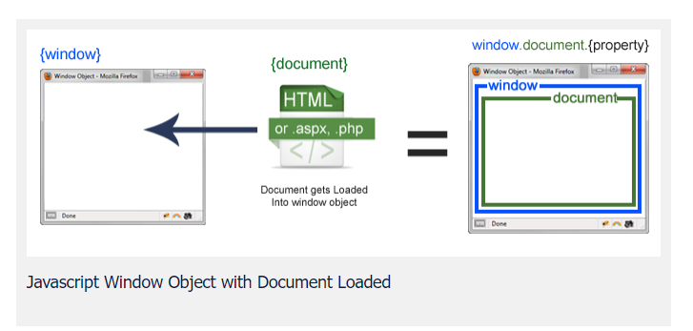

Window Object:

It is the top most object and outermost element of the object.

